Project Report

Project: Use Alexa Voice Command to Control Devices At home

Blinking LEDs using Alexa voice control, IFTTT and Particle Photon

Submitted by

-Team Swetha

1. Abstract

The purpose of this project is to blink the LEDs using the hardware –particle photon and Alexa voice commands by creating IFTTT recipes. This report will explain the requirements and procedure to synthesize a test and troubleshoot the system we had to build as well as the technique we had to implement and efficiently completing this as a team.

2. Prerequisites for Setup

* **Software**
  + Particle Mobile App - [iPhone](https://itunes.apple.com/us/app/particle-build-photon-electron/id991459054?ls=1&mt=8) | [Android](https://play.google.com/store/apps/details?id=io.particle.android.app)
  + The online IDE or a local Particle dev
* **Hardware**
  + Particle device (Photon)
  + USB to micro USB cable (included with Photon Kit and Maker Kit)
  + Power source for USB cable (such as your computer, USB battery, or power brick)
  + IPhone or Android smartphone.
  + (1) Resistor between 220 Ohms and 1000 Ohms (1000 Ohms considered in the hardware setup)
  + (3) LEDs , any colour
* **Wi-Fi**

3. System Description

‘

## Blink LED’s

### INTRO

Blinking an LED is the ["Hello World"](http://en.wikipedia.org/wiki/Hello_world_program) example of the microcontroller universe. It's a nice way to warm up and start your journey into the land of embedded hardware.

Particle’s IoT (Internet of Things) Hardware development kit, the ***photon,*** provides everything we need to build a complete project which is connected to the cloud.

IFTTT is a free online automation service that lets us create our own automated “recipes” using an “if this, then that” approach.

Amazon Echo is a hands-free speaker that can be controlled by our voice. Echo

Connects to the Alexa voice service to play music, provide information, news and many more.

### SETUP

Connect the three LEDs, resistor together as shown in the image below to pins D0, D1 and D2 respectively. The negative (shorter) pin of the LEDs are connected to ground via a resistor and the positive (longer) pin is connected to D0, D1 and D2.

Write the code in the Web IDE (particle build), save, verify and flash the code onto the device. Create IFTTT recipe and implement it using Amazon Echosim.

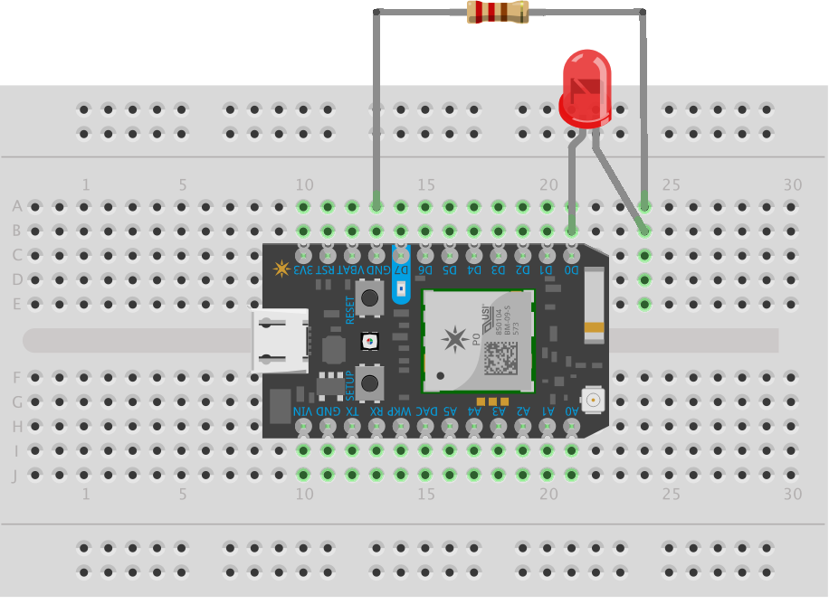 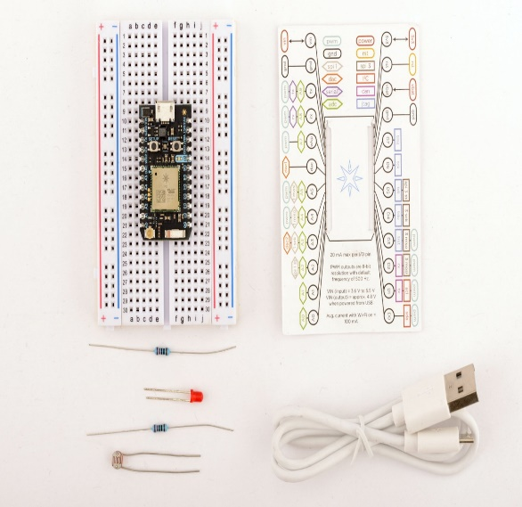

4.CODE 1:

// initialising variables

int led1= D0;

int led2= D1;

int led3= D2;

void setup()

{

pinMode(led1,OUTPUT);

pinMode(led2,OUTPUT);

pinMode(led3,OUTPUT);

Particle.function(“red_led”,blink);

}

Void loop ()

{

//repeat

}

int blink(string command)

{

digitalWrite(led1,HIGH);

digitalWrite(led2,HIGH);

digitalWrite(led3,HIGH);

delay(1000);

digitalWrite(led1,LOW);

digitalWrite(led2,LOW);

digitalWrite(led3,LOW);

delay (1000);

return 0;

}

CODE 2:

//initialising the LEDs

int led1 = D0;

int led2 = D1;

int led3 = D2;

void setup() {

pinMode(led1, OUTPUT);

pinMode(led2, OUTPUT);

pinMode(led3, OUTPUT);

Particle.function("led", blink);

Particle.function("red_led", blink1);

}

void loop () {

// loop repeat

}

int blink(String command) {

// to blink the LED, first we'll turn it on

digitalWrite(led1, HIGH);

digitalWrite(led2, HIGH);

digitalWrite(led3, HIGH);

delay(1000);

// Then we'll turn it off

digitalWrite(led1, LOW);

digitalWrite(led2, LOW);

digitalWrite(led3, LOW);

// Wait 1 second

delay(1000);

return 0;

}

int blink1(String command1) {

// to blink the red LEDs, we first turn on the LEDs

digitalWrite(led1, HIGH);

digitalWrite(led2, LOW);

digitalWrite(led3, HIGH);

delay(1000);

//then we turn off the LEDs

digitalWrite(led1, HIGH);

digitalWrite(led2, LOW);

digitalWrite(led3, HIGH);

return 0;

}

5.Conclusions and Challenges

We learned about the IoT with the help of the kit –photon. We learned about the particle photon and we implemented that in our project to blink the LEDs. We created recipes using IFTTT (If this, then that) and used Alexa voice control command-“Alexa trigger blink my led” as the trigger of the IFTTT and called a function as the action under the created recipe using IFTTT and Alexa.

We initially faced challenges while writing the code for the project and while implementing them with IFTTT. However through team work and assistance we have successfully completed the project.